Final Project Report

To Teacher Quang Hoang Cao

By Anh Khoi Nguyen 2032488

Project Description

The property management website is programmed in ASP.NET MVC. It allows users to do different tasks depending on the user’s roles. It is used to showcase properties, buildings, and apartments to potential tenants and help the property manager to communicate with potential tenants.

Project Development

Phrase 1 Analysis

I need to have different roles for users so that depending on the roles they can have different access to the website

I need to have a database to store users and property data, as well as storing text between users.

Tables need to have relation to each other

Phrase 2 Design

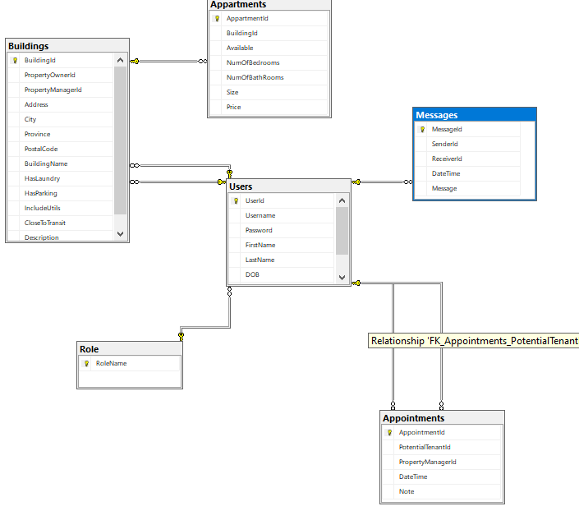

Phrase 3 Implementation

Create a common landing page

Require login to access other pages

Have different pages with different tasks(to view, create, edit ,delete) for each table beside

Phrase 4 Testing

|  |  |  |
| --- | --- | --- |
| User | Test | Result |
| Property Owner, Administrator | Create any property manager account |  |
| Property Owner, Administrator | Update any property manager account |  |
| Property Owner, Administrator | Delete any property manager account |  |
| Property Owner, Administrator | Search any property manager account |  |
| Property Owner, Administrator | List any property manager account |  |
| Property Owner, Administrator | Update any potential tenant account |  |
| Property Owner, Administrator | Delete any potential tenant account |  |
| Property Owner, Administrator | Search any potential tenant account |  |
| Property Owner, Administrator | List any potential tenant account |  |
| Property Manager | CRUD operations related to buildings |  |
| Property Manager | CRUD operations related to apartments |  |
| Property Manager | Schedule potential tenants ‘appointments |  |
| Property Manager | Respond to potential tenants ‘messages |  |
| Property Manager | Report any events to the property owner when necessary |  |
| Potential Tenants | Create an on-line account |  |
| Potential Tenants | View any apartment suitable for their needs |  |
| Potential Tenants | Make an appointment |  |
| Potential Tenants | Send necessary messages |  |

Conclusion

After this course, I have learned how to create a website using asp.net and asp.net core. I also learned how to connect my website with a database. I also learned how to authenticate and authorize the users.

Bibliography

<https://www.bytehide.com/blog/session-in-mvc>

Stackoverflow